WEEK 3 – Budget a Dream Vacation
Grade: Junior (4-6)
Unit: Number Sense and Numeration
Curriculum Expectation
add and subtract decimal numbers to hundredths, including money amounts, using concrete materials, estimation, and algorithms

Activity
1) Students will use their number sense skills to budget out a dream vacation to take once quarantine has ended
2) Students have a budget of $2500 to plan a trip for two people, they will pick a dream destination and research their dream 3 day trip (use websites such as Google or TripAdvisor for flights, accommodation costs and activities. Estimations are acceptable)
3) Students will fill out the item sheet based on their research, recording the flight, accommodation, and car rental costs as well as deciding on activities and food they would like for their trip
4) Students will then fill in the budget sheet with the items of their choice, adding a 13% tax to the cost of their plans, adjusting as needed to create a trip that gets as close to $2500 as possible without going over.
5) If time permits, find images to add to create a collage of the planned vacation
Note: If access to a computer is unavailable, students can use the pre-made Vancouver budget and choose the pre-priced items from the list in order to fill in the trip budget form, alternatively, if students want extra practice, they can use the pre-filled in item sheet to practice.

Check for Understanding
I could successfully add and subtract money amounts including decimal numbers
I was able to estimate which items I could afford with a set total of $2500
I budgeted successfully to be able to afford a trip

Materials
Recording sheet (attached below), pencil, computer access/ filled in item sheet, calculator (for multiplication) imagination!
Trip to _____________________
Item | Type | Cost (Excluding Tax)
Flight (cost per person) | Non-stop
 | One Stop
Accommodation (Cost per night) | One Bedroom Motel
 | Apartment Rental
 | Family Suite
Car Rental (Cost per day) | Compact
 | Sport Car
 | SUV
Activity (Cost per person)
Food (cost per person) | Breakfast
 | Lunch
 | Dinner
Trip to Vancouver
Item | Type | Cost (Excluding Tax)
Flight (cost per person) | Non-stop | $448.35
 | One Stop | $399.85
Accommodation (Cost per night) | One Bedroom Motel | $95.50
 | Apartment Rental | $120
 | Family Suite | $248.78
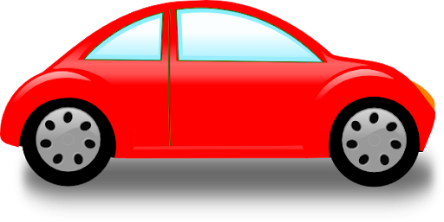  Car Rental (Cost per day) | Compact | $85.55
 | Sport Car | $175.89
 | SUV | $159.99
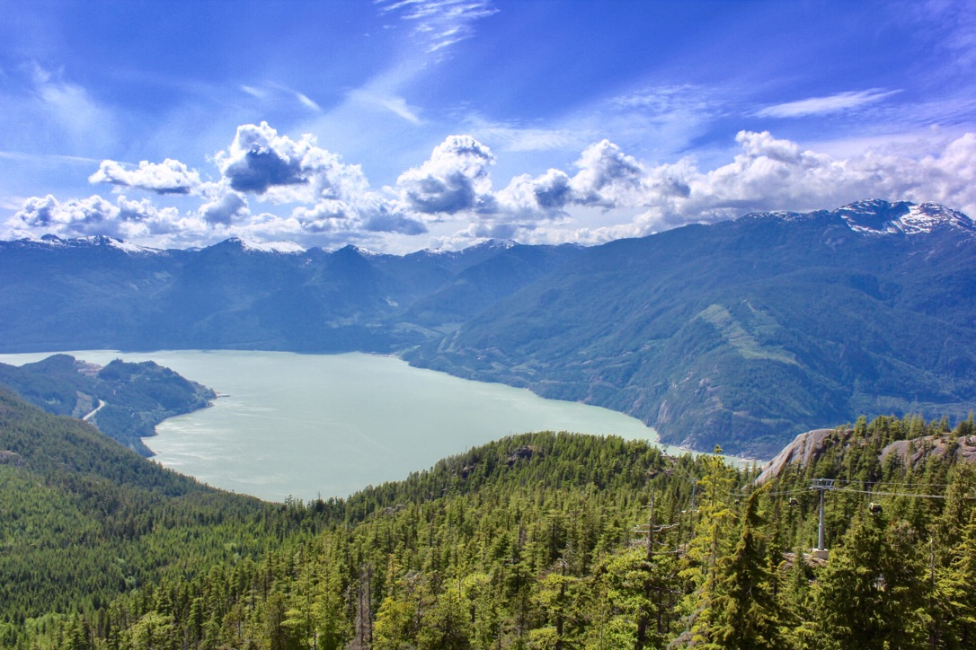  Activity (Cost per person) | Amusement Park | $85.59
 | Museum | $20.50
 | Suspension Bridge | $53.95
 | Walking Tour | $25.99
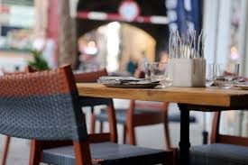  Food (cost per person) | Fast food | $15
 | Family diner | $30
 | Fancy restaurant | $60

Trip Budget
Transportation | Cost for 2 people (Include a 13% tax) | Total Money Remaining
Flight (circle one)  1 stop or non-stop | $____________ x 2 x 1.13 = ___________ | $2500 -____________ = __________
Rental Car Size?  ____________ | $______________ | = _________ - _________= _______
Accommodation | Cost for 3 Nights (Include a 13% tax)
Type?  _____________ | $__________ x 3 x 1.13 = _____________ | =________ - _________=_________
Activities (Pick 3) | Cost for 2 People (Include a 13% tax)
 | $__________ x 2 x 1.13 = _____________
 | $__________ x 2 x 1.13 = _____________
 | $__________ x 2 x 1.13 = _____________
Total Cost for 3 activities | $_____________________ | =_______ - _________ = _________
Food | Cost for two people (Include a 13% tax)
Breakfast | __________ x 2 x 1.13 = __________
Lunch | __________ x 2 x 1.13 = __________
Dinner | __________ x 2 x 1.13 = __________
Total food cost for 3 days | __________ x3 x 1.13 = ___________ | = _______ - _________ = _________
Total Trip Cost | $_____________________ | Total Remaining: $________________

