Unit: Analytic Geometry
WEEK 14 – Shopping for a Phone Plan
Grade: Intermediate (9)
Curriculum Expectations
MPM 1D/MFM 1P: determine graphically the point of intersection of two linear relations, and interpret the intersection point in the context of an application
SEL: make connections between math and everyday contexts to help them make informed judgements and decisions

Activity
1) When shopping for a phone plan, you will be bombarded with a variety of prices and configurations of payments. Today you will learn how to calculate and graph how to save money on your phone bill cost.
2) When you purchase a phone outright and then get a bring your own device plan, it often costs you more upfront but may cost less in the long run, however, if you finance the phone, it may be cheaper in the short term, but could cost more in the long term.
3) You must now go online (or use the list below) and find a series of phone plans comparing prices for similar devices, allotments of minutes, data etc.
4) You will create a table of values (TOV) comparing the monthly cost over 2 years of at least 2 plans, one must be a plan with a discounted phone and one a bring your own phone plan, including the up-front cost of the phone
5) Then you will graph the phone plans, labelling the appropriate axes and giving your graph a title and determine at what point they intersect. This is the point at which the plans cost the same. Which plan is cheaper in total and which would you want?

Check for Understanding
I understand how to compare phone plans in a table of values
I can graph and determine the point of intersection of different linear equations
I understand the relevance of comparing phone prices in my everyday life
Materials
Recording sheet (attached below), pencil, information sheet below or internet access, calculator

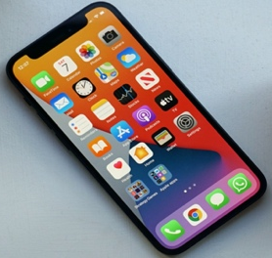

Phone plans for iPhone 12

 | Plan 1 | Plan 2 | Plan 3
Data | 2 GB | 2.5 GB | 2.5 GB
Talk/Text | 400 min/Unlimited | 250 min/Unlimited | 200 min/Unlimited
Upfront phone cost | $0.00 down | $375 | $1100 (BYOD)
Monthly plan cost | $95 | $80 | $40
Locked in? | 24 months | 24 months | N/A

Phone Plan TOV

# Months | Plan 1 | Plan 2 | Plan 3
1

6

12

18

24

