Grade: Intermediate (7-8)
WEEK 13 – Shopping in Foreign Currency
Unit: Financial Literacy
Curriculum Expectations
Identify and compare exchange rates, and convert foreign currencies to Canadian dollars and vice versa
SEL: make connections between math and everyday contexts to help them make informed judgements and decisions
Activity
1) Online shopping has gone way up! But it is not always as easy as just paying the amount that you see. For this activity, you will get to do some shopping for things that you can do during Covid, and will have to convert international currency to CAD (Canadian $)
2) To start, you will be given $1000 CAD to go shopping with
3) You must now go online (or use the list below) and find at least 10 objects that you want to purchase which are priced in foreign currencies
4) You then must find online (or use the legend below) the conversion of that object from the foreign currency to CAD.
5) Once you have converted every amount, pick your favourite items, and try to get as close to $1000 CAD without going over.
6) Fill out your complete recording sheet as you go (below)
Note: Conversion amounts change daily, so what is listed below may not be accurate, but it is the practice that is important
Additional Challenge: Try estimating the amounts that you will spend without using a calculator. This is great practice for when you are travelling and need to know if something is a good price

Check for Understanding
I understand how to convert international currencies to CAD.
I can quickly estimate conversion amounts in my head.
I understand the relevance of converting currencies in my everyday life.
Materials
Recording sheet (attached below), pencil, information sheet below or internet access, calculator

Shopping Tracking List
Item Purchased | Foreign currency the item was purchased in | Amount of item in foreign currency | Amount converted to CAD

Final Items Purchased (List with Prices in CAD) | Total in CAD

Foreign currency | Abbreviation | Conversion to CAD
Indian Rupee | INR | 0.018
Pound Sterling | GBP | 1.73
Euro | EUR | 1.55
American Dollar | USD | 1.31
Japanese Yen | JPY | 0.013
Mexican Peso | MXN | 0.065
South African Rand | ZAR | 0.084
Swedish Krona | KR | 0.15
Australian Dollar | AUD | 0.95
Brazilian Real | BRL | 0.25

Foreign Currency Conversion Chart

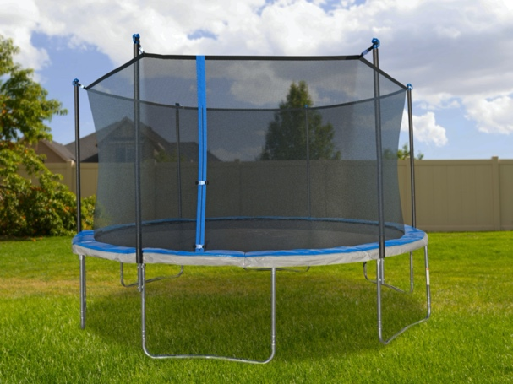
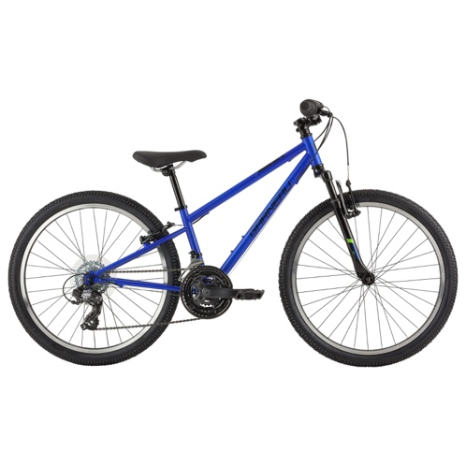

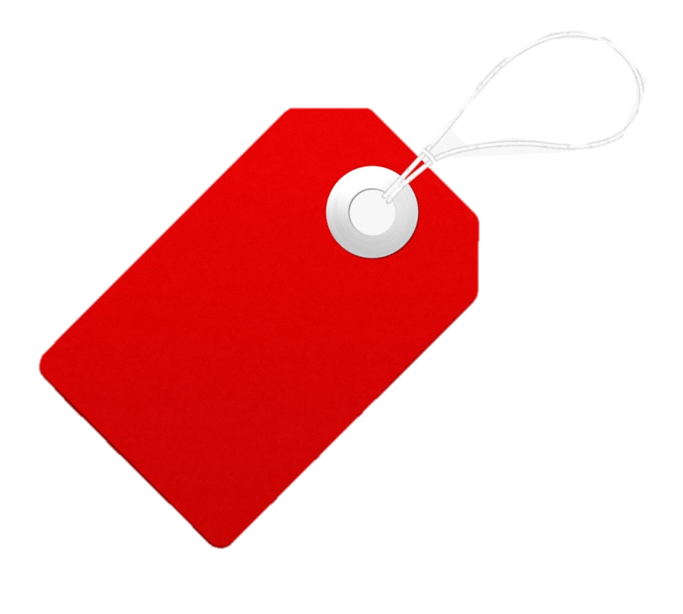
Bike:

250 EUR

Trampoline:

3800 MXN

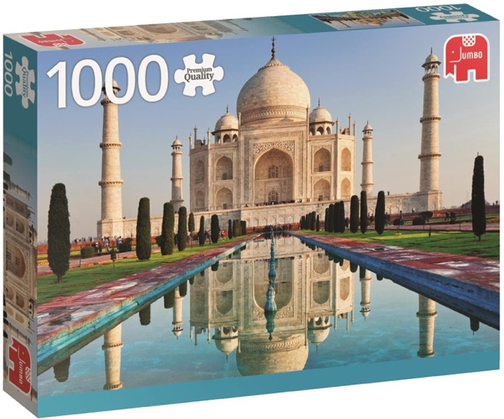
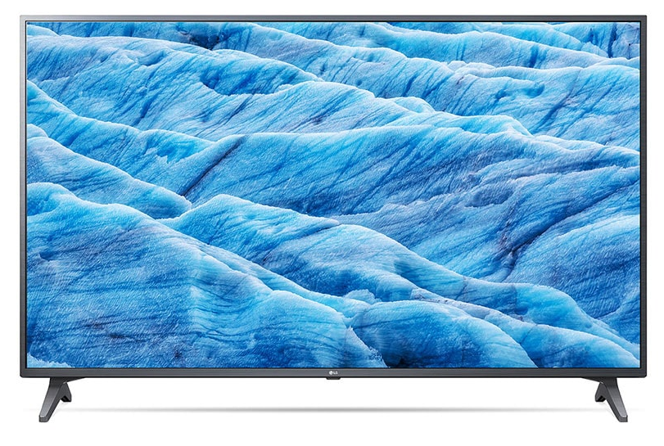

TV:

400 AUD
Puzzle:

1700 INR

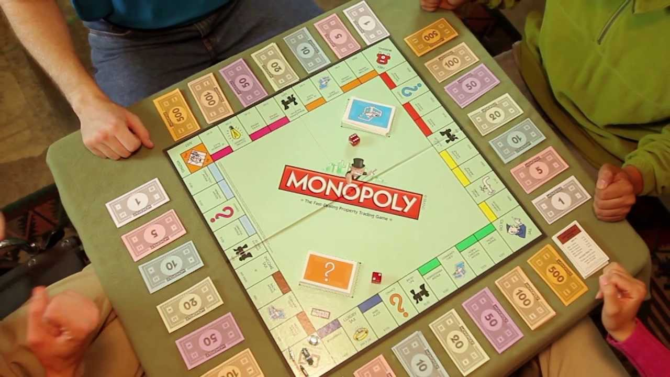

Board Game:

350 ZAR
Gourmet Meal kit for 4:

60 GBP

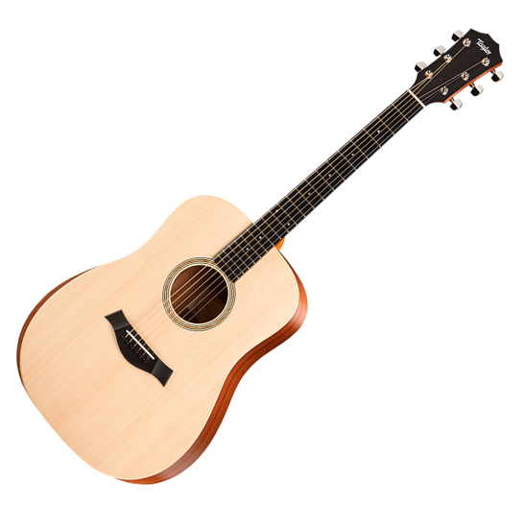

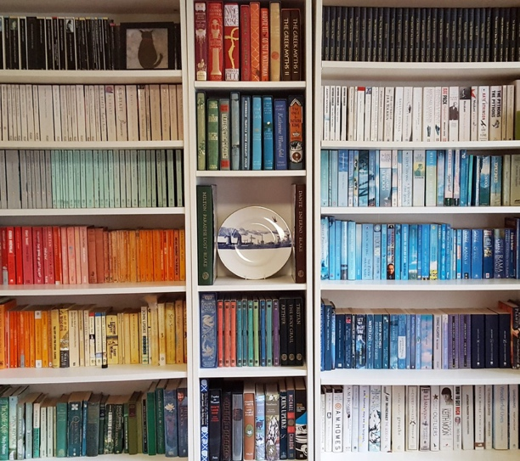

Guitar:

1300 KR
Book Collection:

1000 BRL

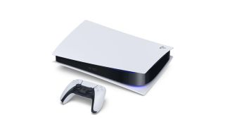

Virtual Aerobics Lessons:
140 USD
PS5:

48,000 JPY

